Bahria University

Karachi Campus



LAB EXPERIMENT NO.

01

LIST OF TASKS

|  |  |
| --- | --- |
| **TASK NO** | **OBJECTIVE** |
| 1 | Enter steps with screenshots for downloading of ubuntu and oracle virtual box. |
| 2 | By using the command line shell interface, practice the commands given in this lab. Write briefly about the usage of each command. |
| 3 | By using gedit, open a text editor and write the C program That print your name. Save the written file as “name.c”. In order to compile and execute the output file, do the following:   * $ gcc - o name name.c * $ ./name |
| 4 | Make changes within the above program to display a new output text as given below. Write down the developed program.   * Hello World! I am studying Operating Systems. * My name is “Enter your name”. * My registration number is “Enter your registration number”. * I belong to Bahria University Karachi Campus. |

Submitted On:

**02-03-2023**

(Date: DD/MM/YY)

**Task # 01:**

**Solution:**

**Step 1:**

Open the official oracle website and click on download button for downloading virtual box.



Download it by clicking on windows link.

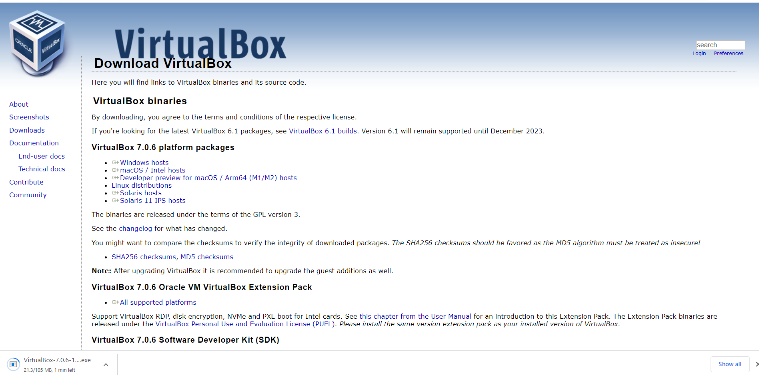

**Step 2:**

After it install its setup.

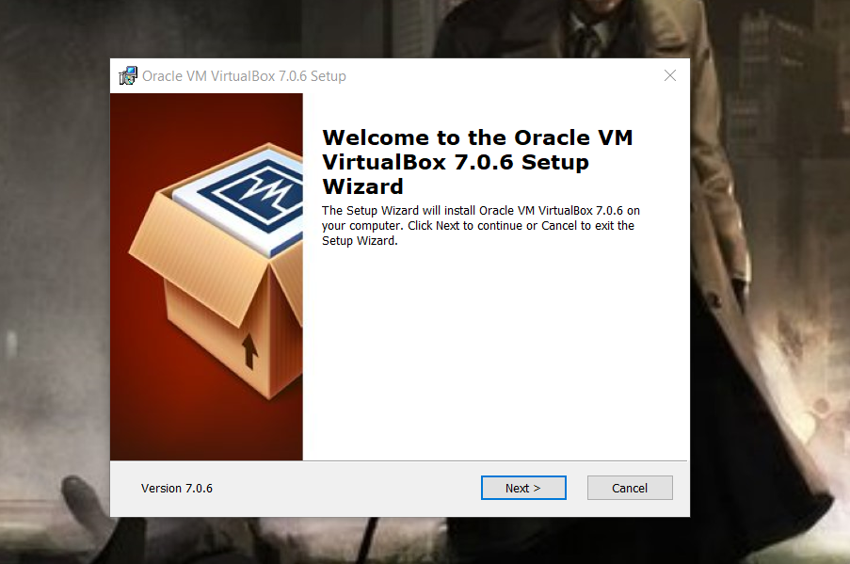

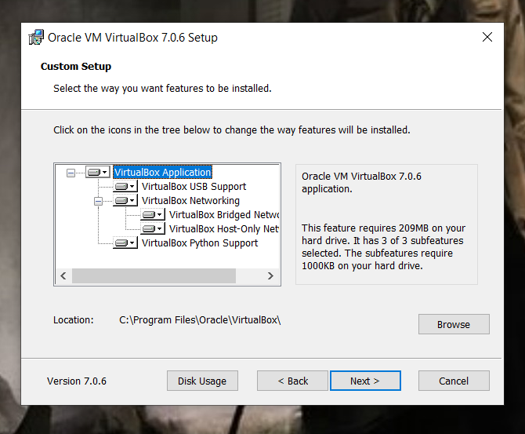

**Step 3:**

After installation a screen will appear like below not download ubuntu for it.

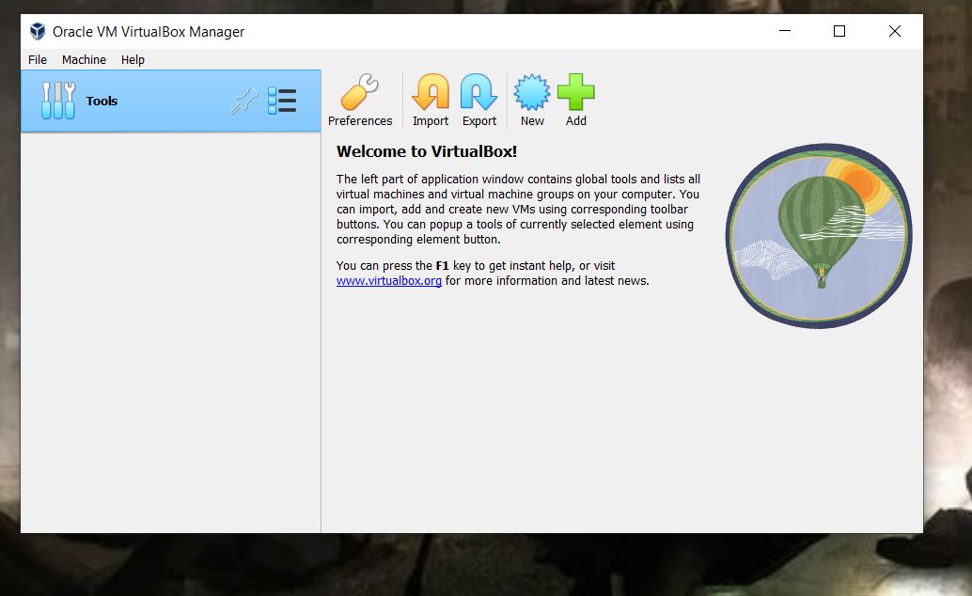

**Step 4:**

Download ubuntu from its website as below.

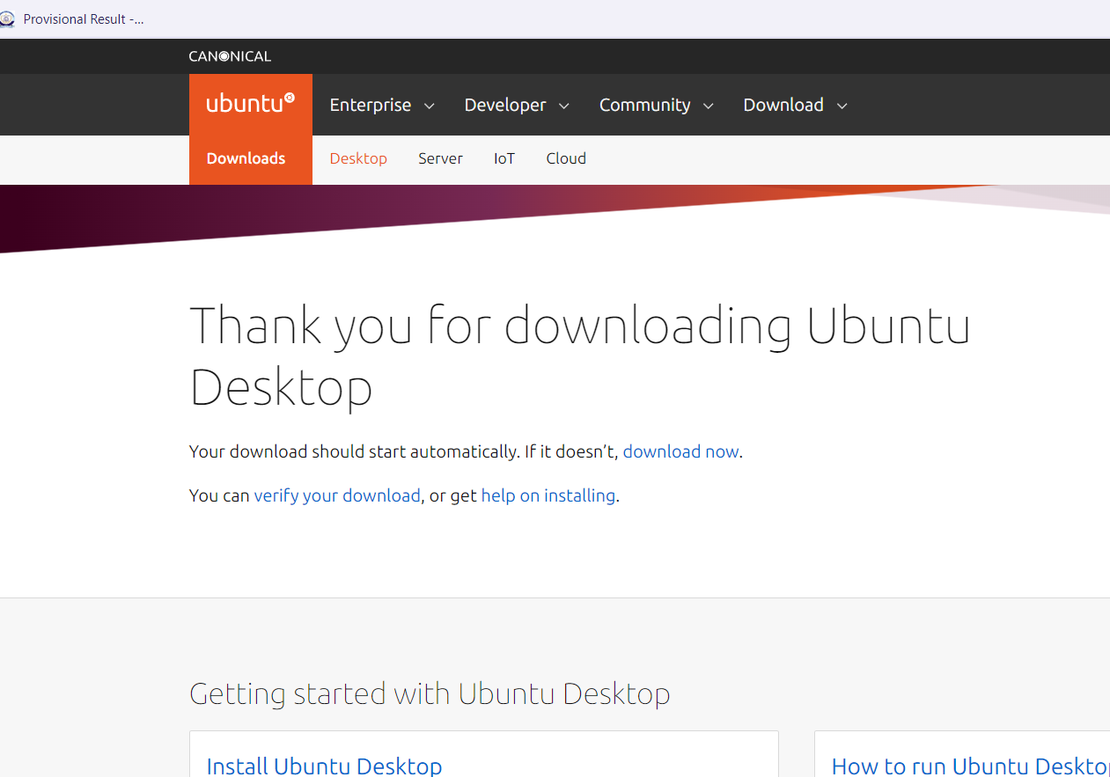

**Step 5:**

Open oracle virtual box and add ubuntu in it by clicking on new button and give its path.

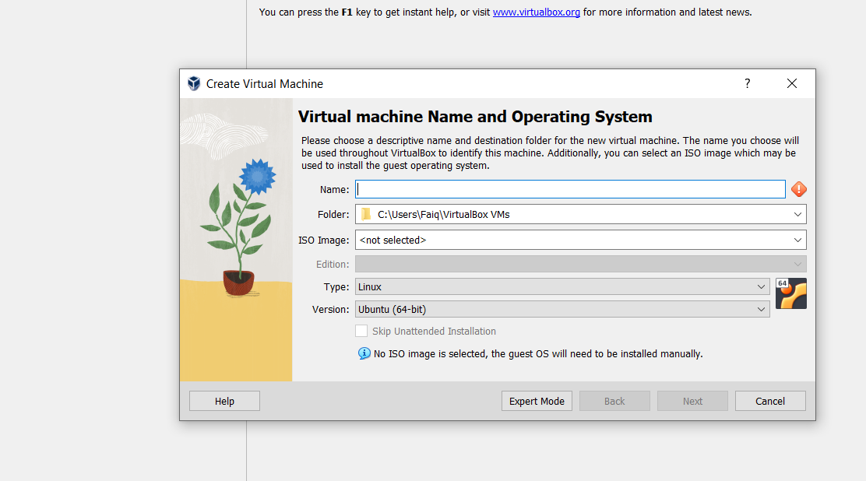

Let it done its process.

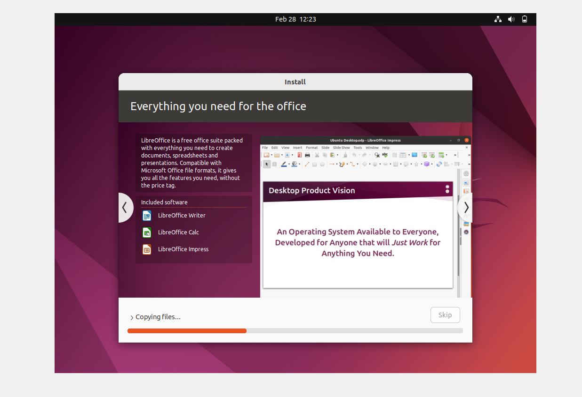

After it click on terminator for commands as below.

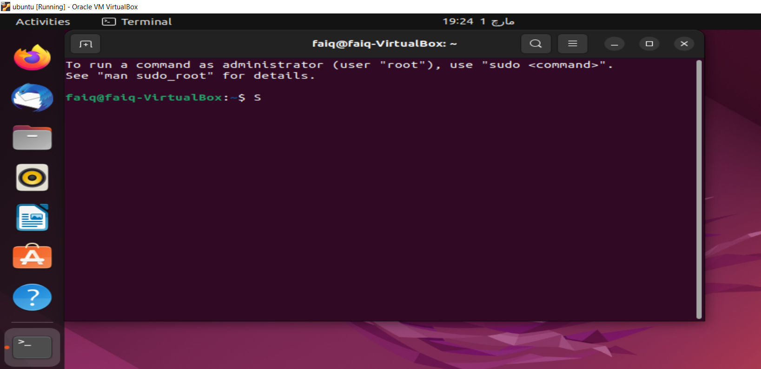

**Task#02**

**Solution:**

Followings below are some of the lab practice commands.

**Output:**

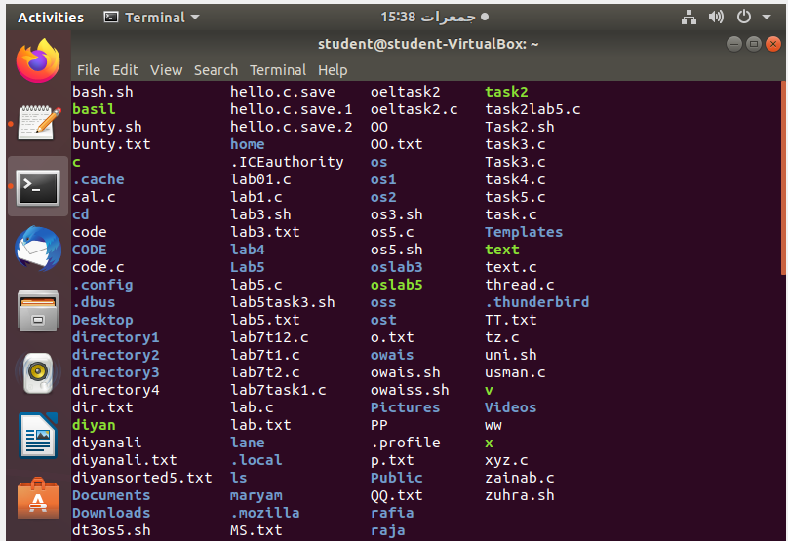





**Task#03**

**Solution:**



File is created.

**Task#04**

**Solution:**

Code in c language .

#include <stdio.h>

int main() {

printf("Hello World! I am studying Operating Systems.\n");

printf("My name is Faiq Bin Sabir.\n");

printf("My registration number is 79317.\n");

printf("I belong to Bahria University Karachi Campus.\n");

return 0;

}

**Output:**

